**Simple Web Blog**

In this assignment you will be responsible for completing a fully functional blog website. This assignment will be divided into multiple parts. You are to show us your progress after completing each of these parts so that we can give you feedback before moving on to the next challenge.

Feel free to contact us for help at any stage of your assignment.

**Part One:**

For the first part of the assignment, you are asked to begin the foundations of your project. We ask you to complete it using the Angular front-end framework. You are to replicate the given design below as close as you can. The given design contains two pages **/blogs** and **/blog/:id** (you will need two extra pages to **add_blog** and **edit_blog** these designs are not provided, you should design them in the same theme). Once the design is complete it is time to add some functionality to your project (you will need to use the Angular Service and Angular Router). You should be able to **add**, **edit**,and **delete** a blog. One blog has the following data: **id**, **category**, **image_url**, **post_date**, **title**, **body**, **author**, **author_title**. To store your blogs when you close the browser, you may save them in local storage.

/blogs

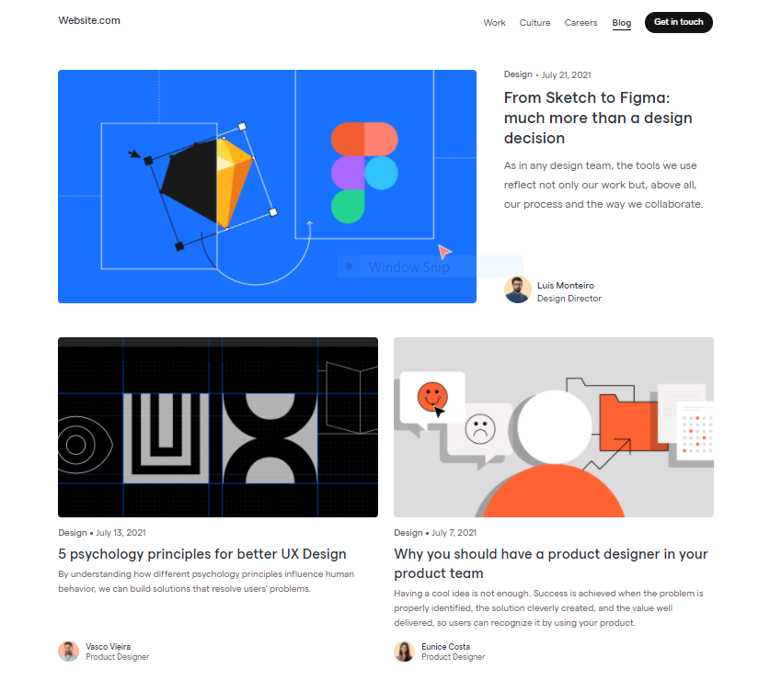

/blog/:id

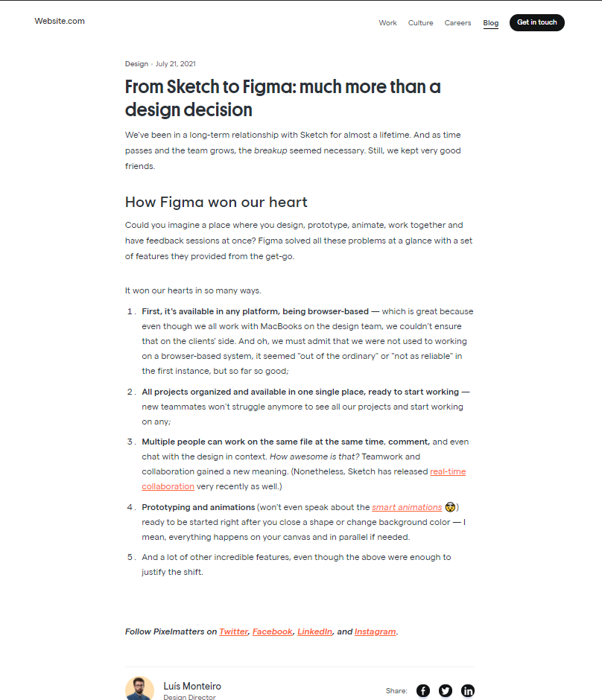

**Part Two (Advanced)**:

For the second and final part, we want to start storing our blogs onto a MongoDB database. To do this we will need to set up a Node.js server as middleware between our Angular app and our MongoDB database. The server will need routes to **get_blogs**, **post_blog**, and **delete_blog**. You will need to learn a bit of **Node.js**, **Express**, and **mongoose** to complete this challenge. Then finally, you need to edit your Angular Service to communicate with the server.